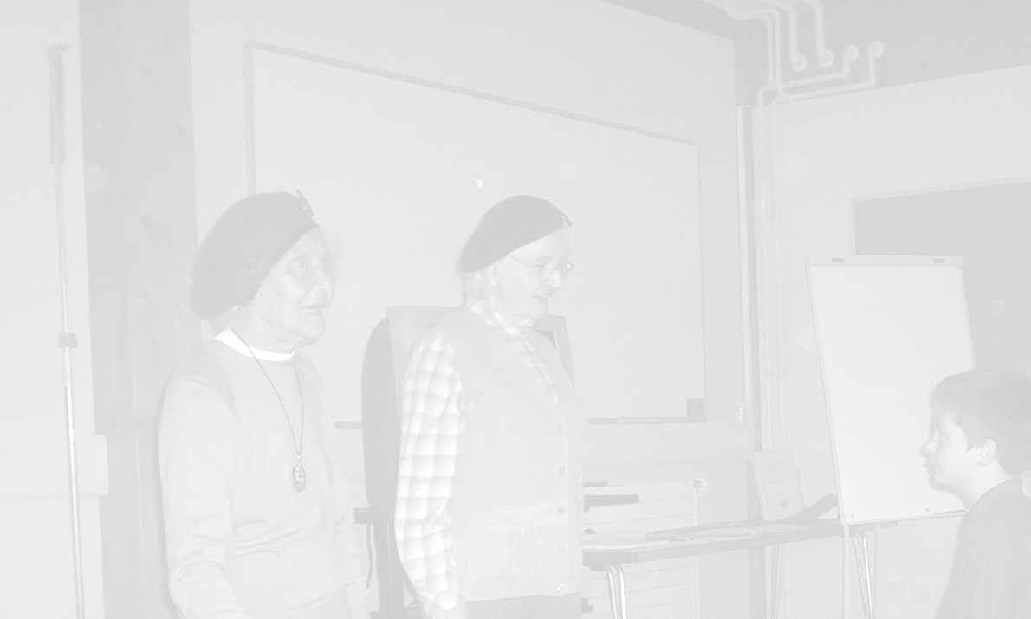

The Importance of the Commonwealth
Key Question How did the commonwealth countries help us during the war?

Objectives
To consider the changing meaning of the commonwealth
To learn about the contribution the commonwealth made to the allied war effort.
To learn more about post war immigration to Britain.

National Curriculum Ref
KS2 Unit 2 a,c Knowledge and understanding of events people and changes in the past.
KS2 Unit 3 Historical Interpretation
KS2 Unit 4a,b Historical Enquiry
KS2 5a,b,c Organisation and Communication
KS2 Unit 7 A local History Study
KS2 Unit 11b Britain since the 1930’s

Resources
Power point presentation for black History Month 2005 see sln website www.sln.dev.staffordshire.gov.uk/history
Maps Atlases
Story of Johnny Smythe

Activity
Give pupils a list of all the commonwealth countries and ask them to locate them on a world map.
What do they think the word Commonwealth means? Why would people want to belong to the commonwealth? What are the responsibilities of the commonwealth?
Show pupils the power point presentation and discuss the points outlined.

Plenary
Ask children to consider these questions
What did the term commonwealth and being British mean to people before during and after the war?

Cross curricular
Geography Enquiry and Skills 1a,c,d,e, 2c,f,
Knowledge and Skills 3a,c,d,e,f,g,
Understanding of Patterns and Process 4a,b
Breadth of Study 6b,d
PSHE
1a Developing Confidence and responsibility and making the most of
Abilities
2a,c, d,efgij, Preparing to play an active role as a citizen
4a, b, d,e,f Developing good relationships and respecting the differences
between people
5g

Opportunities for extension/ICT 1a,b,c,3a,b 4a,b,c 5b
Pupils can research the experiences of Johnny Smythe or other Commonwealth veterans by visiting www.iwm.org.uk/upload/package/11/together/index.htm

They can present a biography of these lives using Power Point.

The Story Of Johnny Smythe

Johnny Smythe did not have to go to war. He was one of 55 000 people from Africa who volunteered to help Britain stop Hitler’s Germany. After Johnny’s plane was shot down over Germany, he spent 18 months in a Prisoner of War camp. He remembered what happened after the Russian Army liberated his camp. ‘They took me to a town near the camp and I watched as they looted. A pretty German woman was crying because they had taken all her valuables. I wanted to help her but the Russians wouldn’t listen. I had hated the Germans and wanted to kill them all, but something changed inside me when I saw her tears and the hopelessness on her face.’

‘We were flying at 16 000 feet when the fighters came out of nowhere. They raked the fuselage and there were flames everywhere. Then the searchlights caught us. I was hit by shrapnel. Pieces came from underneath, piercing my abdomen, going through my side. Another came through my seat and into my groin. I heard the pilot ordering us to bail out! We had some rough ones before but this seemed to be the end. I have tried to forget that night for 50 years.’
Johnny was captured and sent tostalag Luft I, a prisoner of war camp for almost 9000 Allied airmen. Johnny helped other prisoners try to escape but did not try to break out himself. He said, ‘I don’t think a six-foot-five black man would’ve got very far in Pomerania.’ Today there is a memorial at Stalag Luft I. In 2001, veterans and their families from America, Britain, Germany and Russia met
When Johnny was captured, he remembers;
‘The Germans couldn’t believe their eyes. I’m sure that’s what saved me from being shot immediately. To see a black man - and an officer at that - was more than they could come to terms with. They just stood there gazing.

Johnny volunteered to join the RAF because he hated Hitler for his racism. Jesse Owens won four gold medals at the 1936 Berlin Olympics but Hitler refused to shake his hand because he was African American.

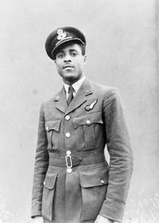
Johnny Smythe

 | People from all over the world helped Britain fight
  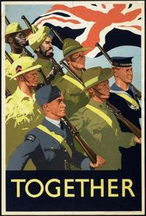
   | Population | Served | Killed or missing | Wounded
  India | 384,000,000 | 2,500,000 | 36,092 | 64,354
  African Colonies | 42,000,000 | 372,000 | 3,387 | 5,549
  Canada/New Zealand/South Africa/Australia | 32,000,000 | 1,757,000 | 82,600 | 103,500
  West Indies | 14,000,000 | 10,000 | 236 | 265
  United Kingdom | 46,000,000 | 4,700,000 | 305,770 | 277,077

