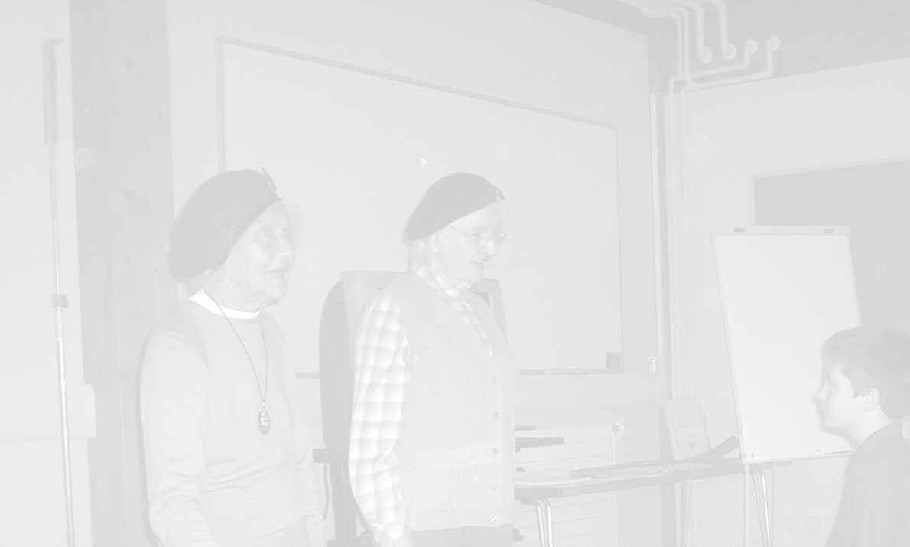
Concept Collage
Key Question
What have I learned about WW2?
What things have made me think most?
How can I show/ commemorate the main important points using artefacts available to me?

Objectives
To commemorate the war in an unusual, personal and meaningful way.

National Curriculum Ref
KS2 Unit 2 a,c Knowledge and understanding of events people and changes in the past.
KS2 Unit 3 Historical Interpretation
KS2 Unit 4a,b Historical Enquiry
KS2 5a,b,c Organisation and Communication
KS2 Unit 11b Britain since the 1930’s

Resources
Items to copy or use for collage
Photographs, letters, documents, diaries, postcards, own drawings, transcripts, recipes, menus, cartoons, newspaper clippings, rubbings, sketches, small artefacts (placed in sandwich bags/plastic wallets for protection)

Activity
Ask the pupils to consider the above Key Questions.
Give them time to accumulate the materials they need to produce their collage. Help may be needed for photocopying original materials that the children wish to include.
Encourage pupils to display their chosen materials in an eye catching way, spending quality time designing the collage before using adhesive.
Pupils create collages on large sheets of card.

Plenary
.Pupils display their work in a central place in school and have time to reflect on the work of peers.

Cross curricular
Art and Design
1a, b,c Exploring and developing ideas
2, b,c Investigating and making art, craft design
3a, b Evaluating and developing work
4a, b,c Knowledge and understanding
5a,c, d Breadth of study

Opportunities for Extension
Elderly citizens and veteran groups could be invited into school to view the concept collages. This could form part of an enrichment afternoon/ day where children could present other examples of their investigations into the Second World War.
ie plays, letters, art work, videos, cooking, , artefacts, memories photos,etc

Opportunities for ICT 3a,b, 4a,b,c 5b,c
Photos of the day could be recorded and posted onto the school website or an article written in the school newspaper.

